1. **Agenda**: A few more methods related to threads.
2. thread1.setName(“name”):
   1. **Application**: if we’re crawling 10 web sites and for each site, we have one thread. So currently which web site is being crawled, for this thread.setName();
3. 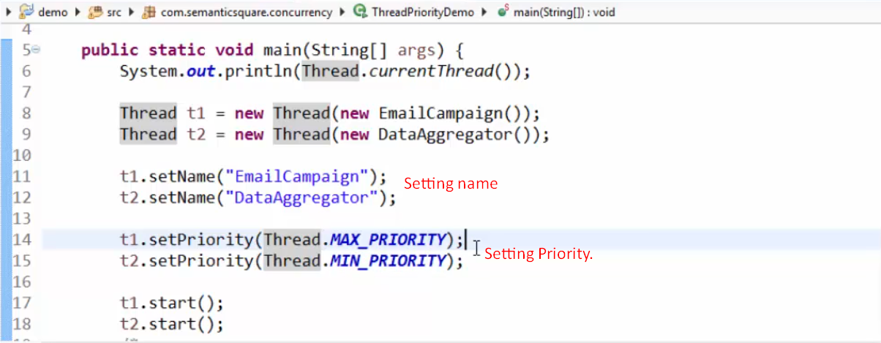
4. **Thread.currentThread.yield()**: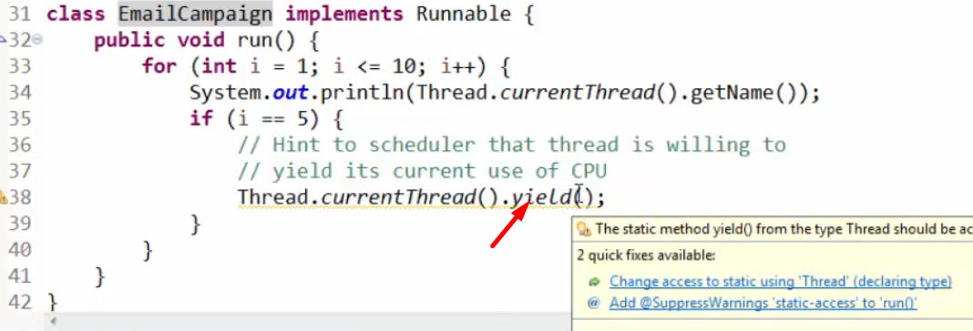
5. **Join()**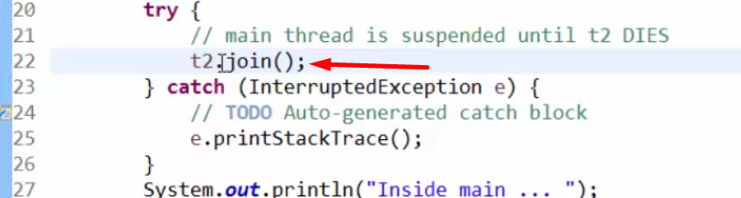
6. 